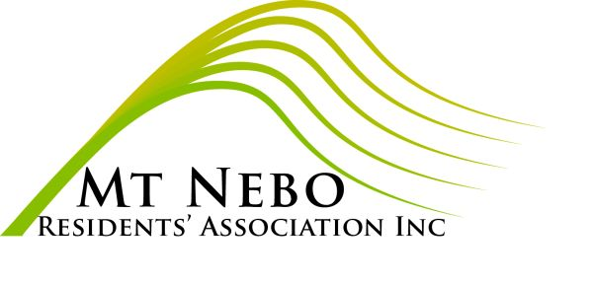

MANAGEMENT COMMITTEE NOMINATION FORM 2021

To:

The Secretary, Mt Nebo Residents’ Association Inc:

I, ……………………………… hereby nominate ……………………………to serve on

the Management Committee of the Mt Nebo Residents’ Association Inc in the

position of …………………………………………….. Signed ……………………………

!, ……………………………… hereby second this nomination. Signed ………………...

I, ………………………………. accept this nomination. Signed ………………………….

Received / /2021

………………………

Carmel Black
Hon Secretary
Mt Nebo Residents’ Association Inc

