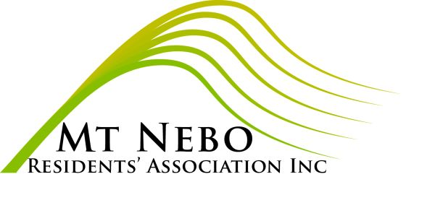 NOTICE of the ANNUAL GENERAL MEETING of the MOUNT NEBO RESIDENTS’ ASSOCIATION INC

To be held on Wednesday, 2 March 2022,
commencing 7.30 pm at Mt Nebo Hall, View St

AGENDA for the 2022 ANNUAL GENERAL MEETING

1 To receive the Minutes of the 2021 Annual General Meeting
2 To receive the Annual Report of the President and Management Committee
3 To receive the Statements of Accounts for 2021
4 Election of President, Vice President, Secretary and Treasurer
5 Appointment of an Auditor
6 Any other business

Carmel Black, Secretary (for the Management Committee)

MOUNT NEBO RESIDENTS’ ASSOCIATION INC
PO Box 135 Mt Nebo QLD 4520

NOMINATION FORM

For the election of President, Vice President, Secretary, Treasurer, and member of the Management Committee at the Annual General Meeting to be held on Wednesday 2 March 2022.

Nominations are required to be in the hands of the Secretary on or before 16 February, via the postal address shown above or email to Carmel.Black2@bigpond.com

Nominations must be signed by 2 (two) Ordinary members of the Mt Nebo Residents’ Association Inc and be accompanied by the written consent of the nominee.

We nominate ......................................................

for the office of ......................................................

Signed ......................................................

Signed ......................................................

If elected I agree to act in the position of

......................................................

Signature ......................................................

Date Received ......................................................

Hon. Secretary ......................................................

MOUNT NEBO RESIDENTS’ ASSOCIATION INC
PO Box 135 Mt Nebo QLD 4520

PROXY FORM

I, ............................................…………………….

of ...................................................……………….

being an ordinary member of the above-named Association, hereby appoint: .................................

………………………………………………………….

of ............................................................................

……………………………………………………..…..

Or, failing that person, I appoint .........................

………………………………………………………….

of .................................................................

………...……………………………………………….

as my proxy to vote for me on my behalf at the Annual General Meeting of the association, to be held on Wednesday 2 March 2022, and at any adjournment thereof.

Signed this ........….. day of …........................2022

Signature ..........................................……………...

