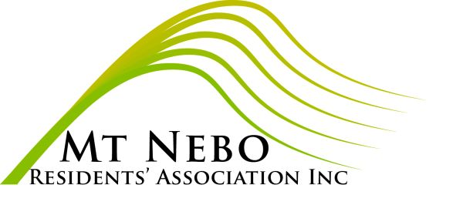 NOTICE of a SPECIAL GENERAL MEETING of the MOUNT NEBO RESIDENTS’ ASSOCIATION INC

To be held on Wednesday, 6 April 2022,
commencing 7.30 pm at Mt Nebo Hall, View St

AGENDA for the 2022 SPECIAL GENERAL MEETING

1. To receive the Minutes of the 2021 Annual General Meeting;
2. To receive the Association’s financial statement and signed statements for the 2021 financial year.

Carmel Black, Secretary (for the Management Committee)

MOUNT NEBO RESIDENTS’ ASSOCIATION INC
PO Box 135 Mt Nebo QLD 4520

PROXY FORM

I, ............................................…………………….

of ...................................................……………….

being an ordinary member of the above-named Association, hereby appoint:

………………………………………………………….

of ............................................................................

……………………………………………………..…..

Or, failing that person, I appoint .........................

………………………………………………………….

of .................................................................

………...……………………………………………….

as my proxy to vote for me on my behalf at the Special General Meeting of the association, to be held on Wednesday 6 April 2022, and at any adjournment thereof.

Signed this ........….. day of …........................2022

Signature ..........................................……………...

