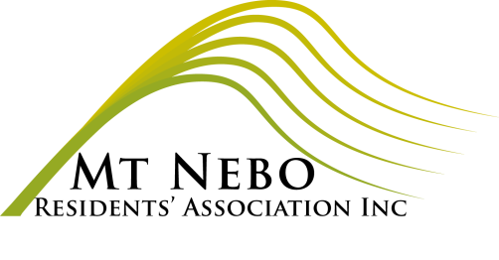
MOUNT NEBO RESIDENTS’ ASSOCIATION INC
GENERAL MEETING

MINUTES

Meeting 3 August, 2022

PRESENT: Julia Hocking, Karen Mungomery, Di Clark

APOLOGIES: Carmel Black, Lincoln Hudson

Meeting opened 7.32pm

AGENDA ITEM | DISCUSSION | OUTCOME/ACTION
Minutes of previous meeting | Minutes from May and July to be accepted | Moved Karen – 2nd Di  Pased
New members: | 10/07/2022 Michelle Allan | Address to be confirmed prior to M’ship acceptance
Correspondence | Inwards:  05/07/22 Rob Lachowicz Invitation to Unveiling of poles at Jinibara recognition site  07/07/22 Westpac notification of EFTPOS upgrade  16/07/22 Meegan Hardaker local wholesale cooperative food group quote for hall hire  18/07/22 Annual Return payment request for Liquor, Gaming and Fair Trading office  29/07/22 Samford Community Forum invitation  Outwards  16/07/22 Julia Hocking quote for hall hire to Meegan @ $30/hr  30/07/22 Karen Mungomery invoice request to Ryan Smith for hall cleaning and maintenance | Offer to use Blue Room for $20 – Julia to follow-up  Carmel to attend  See action above  Moved Karen – 2nd Di - accepted
Treasurer’s Report | See attached report | Tabled Karen Moved Di – 2nd Julia - accepted
Disaster Management Group |  | N/A
Rural Fire Brigade |  | N/A
Grant funding update |  | N/A
Roads update |  | See attached . Lincoln to follow up
Hall | Upcoming events:  05/08 pub night  16/10 wedding– Alea Paletta | Hall is becoming increasingly busy - Ryan to be approached to be Hall caretaker – Julia. No Sept pub night- Mt Idol on 10/9 P&C to cater. Daren Grimwade to be invited to Mt Idol.  Sunday Wedding – Musos afternoon participants to be approached to help clear fridge for use by wedding.  Wendy to be advised that hall clean may be an issue as Yoga is early start on Monday.
Jinibara Project | First Peoples Recognition Site Artwork and Information Poles unveiling 10/07 @ 11am | Completed. All Accounts paid inc. contribution to Jinibara project. Account now closed.
General business |  | Spring Dance 1 Oct. 6. 30 – 11pm. Finger food eg Burgers/Pies. Julia to approach Angela and James. Di to organise Banner – must include MBRC logo as sponsor

Meeting closed 8.05pm
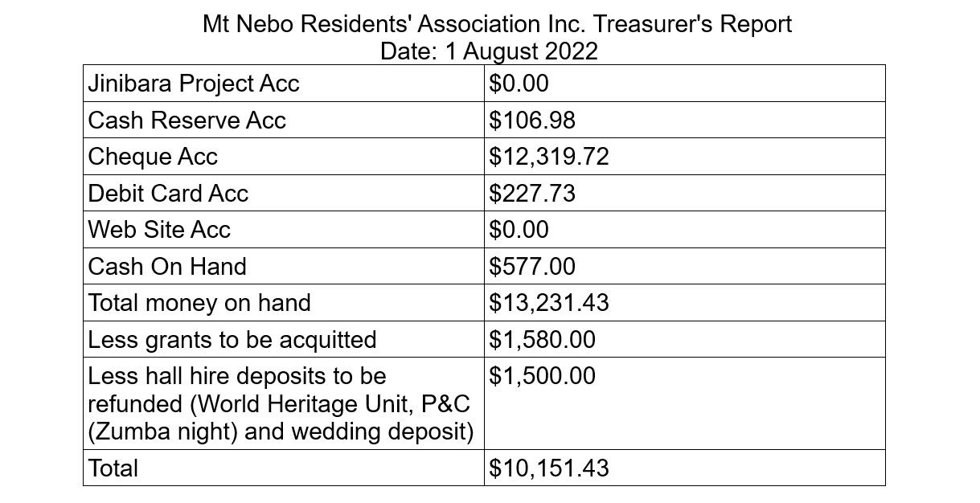
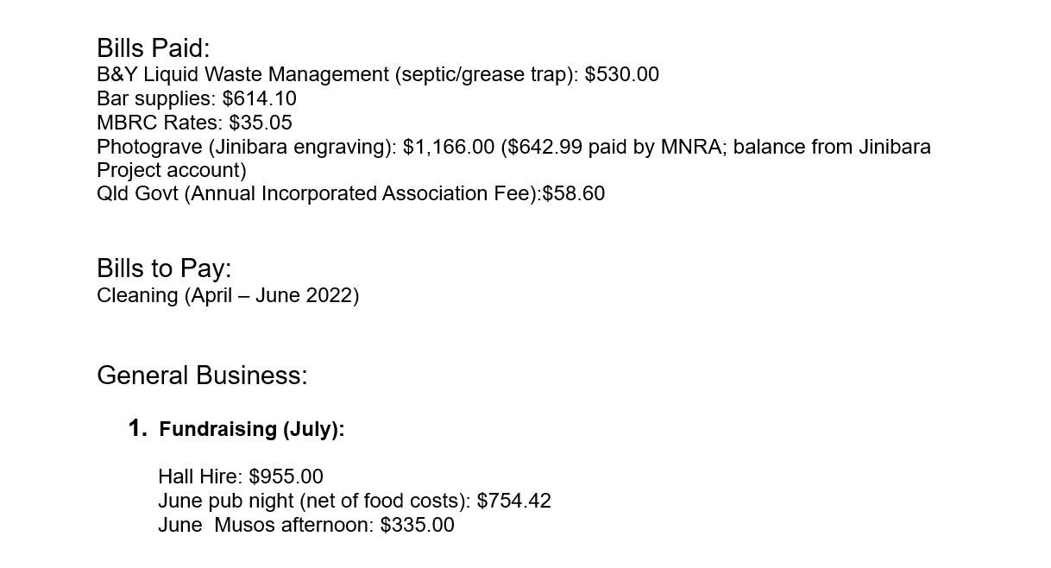

MBRC Roads update

-------- Forwarded Message --------
Subject:RE: Mount Nebo Rd repairs update for the Resident's Association meeting
Date:Wed, 6 Jul 2022 04:07:57 +0000
From:Fiona Burrows <Fiona.Burrows@moretonbay.qld.gov.au>
To:Lincoln Hudson <lincolnbh@fastmail.com.au>
CC:Darren Grimwade <Darren.Grimwade@moretonbay.qld.gov.au>

Hi Lincoln,

Please find below some information for the community for tonight's meeting.

Advice has been received that there are currently two projects where council is seeking funding from the Queensland Reconstruction Authority (QRA) and are awaiting approval to progress these works. Works at these locations may still be a few months away.

The locations are:
- 2295 Mt Nebo Road - Landslip
- Mt Nebo Road near Goat Track Clean-up of Slip.

Inspections are being carried out on Darcy Kelly Road and Mt Nebo Road and maintenance works will be carried out as required. If there are specific requests that residents have lodged and feel are not being actioned please ask them to contact me and I will be happy to follow them up and provide an update.

Advice regarding the Goat Track is that final investigations are being carried out with the intention that it can be re- opened with a load limit imposed after the completion of some ‘make safe’ works. These ‘make safe’ works will need to be done in the dry weather but it is not anticipated that they will take long and it could be only a matter of weeks until the road is open again.

Councillor Grimwade has asked me to pass on his apology as he is unable to attend tonight's meeting, but as always, if there are any council issues arising from the meeting please get in touch with Councillor Grimwade or myself.
Kind Regards Fiona Burrows
Personal Assistant to Councillor Grimwade - Division 11
Moreton Bay Regional Council

BCC Roads update

-------- Forwarded Message --------
Subject:RE: Mount Nebo Rd repairs update for the Resident's Association meeting
Date:Wed, 6 Jul 2022 03:15:42 +0000
From:TheGap Ward Office <TheGap.Ward@bcc.qld.gov.au>
To:'Lincoln Hudson' <lincolnbh@fastmail.com.au>

Good afternoon Lincoln

Thank you for the email, please see the information below for your meeting tonight.

Brisbane City Council did some urgent maintenance repairs on some large failures a couple of weeks ago.

The resurfacing scheduled to commence in a few weeks - this will cover Stage 2 and Stage 3 (Brompton Rd to Bellbird Park) and we will also pick up additional failures between Bellbird Park and the Council boundary.

The project will involve removing the existing top layer. This will be a mixture of gravel and asphalt materials which would be good for driveways or hardstand areas. If any landowners would like some material for their properties, we would be willing to sell the material rather than cart the material back into Brisbane.

If this could be passed onto the residents' association and any interested property owners can contact our office on 3403 1044.

Thanks Adele
Adele Fahey Senior Ward Officer
The Gap Ward | BRISBANE CITY COUNCIL

...........................................................................................................
477 Waterworks Road, Ashgrove QLD 4000
Phone: 07 3407 1900| Email: thegap.ward@bcc.qld.gov.au

