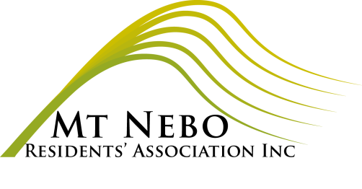
MOUNT NEBO RESIDENTS’ ASSOCIATION INC
GENERAL MEETING

MINUTES

Meeting 7 September, 2022

PRESENT: Carmel Black, Di Clark, Karen Mungomery, Cathy Rough.

APOLOGIES: Julia Hocking, Ross MacLeod, Rob Lachowicz

Meeting opened 7.30pm

AGENDA ITEM | DISCUSSION | OUTCOME/ACTION
Welcome | Acting president, Di Clark, welcomed those present and acknowledged the Jinibara & elders on whose traditional land we meet and live.
Minutes of previous meeting | Copies of the minutes were available. | Karen M moved, seconded by Carmel B that they be accepted.
New members: | 10/07/2022 Michelle Allan address?  20/08/2022 Name: espituda espituda? Email: ocuyul@mnawl.sibicomail.com | Carmel to confirm Michelle Allan’s address.  This notification was obviously spam.
Correspondence | Inwards:  24/8/22 D-G DES application for grant for Renewable Energy Storage and efficiency for hall unsuccessful.  17/8, 18/8, 19/8 Cc into corres between Don Francis and Cr Grimwade re road maintenance.  Outwards:  1/8/22 MNRA Treasurer requesting invoice from cleaner/maintenance. | Carmel B moved, seconded by Cathy R that the correspondence record be accepted.  Carmel to contact Cartlin about lack of invoices.
Treasurer’s Report | See Appendix 1 | Karen M moved, secnded Carmel B that the report be accepted.
Disaster Management Group | Cathy Rough reported that there are two deputies, Lucy Francis and Andrea Mitchell. There have been social functions and meetings with MBRC.
Rural Fire Brigade | NA
Grant funding update | See Treasurer’s report.
Roads update | Good to see work being done, although there is a lack of warning signs on some steep transitions.
Hall | Mountain Idol this Saturday.  Rodent problem in store room – chewing water bottles  & chips.  Spring Dance 1 October.  Children’s Birthday party in Blue Room. | Di to remind Wendy to remove yoga gear.  Carmel to talk to Greg Durrington and Ryan Smith about possible solutions that don’t involve poison.  Carmel to invite MBRC sponsors.  Di to liaise.
General business  Community Grant Forum Report  Website | Carmel attended on 16 August. Focus large projects for Samford Village and Samford Valley to bring more business to area. Range of projects, park’n’ride, water park, rail trail, votes taken. A few area-specific for local teenagers. Results being analysed. Small projects encouraged to apply for upcoming grants.  https://www.facebook.com/communitybanksamford  and https://www.facebook.com/SDPPAInc  Di raised issue of difficulty accessing and making bookings for the hall via the website on a smart phone. | Di to contact web manager Julie Lawrence.

Meeting closed: 8.13pm

Appendix 1:
